Lesson 5 Guided Notes
Order of Operations

When there is _______________________ addition or subtraction step within a _________________, we take the _______________ in order from ___________ to ________________.

Example: In this problem we first subtract 4 from 9. Then we add 3.

9 – 4 + 3 = 8

If a _____________________________________ is desired, ___________________ are used to show which step is taken ____________.

Example: In the problem below, we first add 4 and 3 to get 7. Then we subtract 7 from 9.

9 – (4 + 3) = 2

These two rules are part of the ______________ for the ________________________________ in mathematics.

Order of operations:

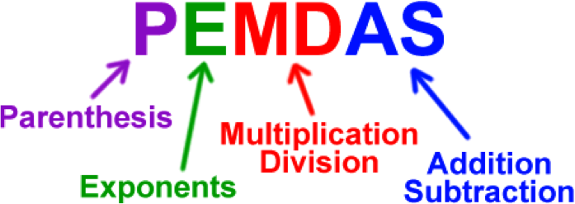
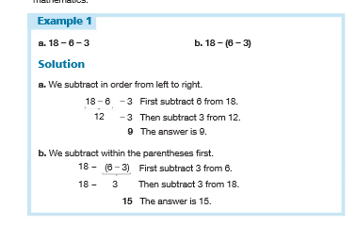

Work out the following examples:

Important note: If there are no parentheses. Solve from left to right.

16 – 3 + 4 =

Important note: If there are parenthesis. Solve parentheses first.

16 – (3 + 4) =

When there is ____________________________ one multiplication or division step within a ________________________ , we take the _____________________ from _____________ to ___________________.

Example: In this problem we divide 24 by 6 and then multiply by 2.
24 6 x 2 = 8

If there are________________________ , then we____________ do the __________ within the parentheses.

Example: In this problem we first multiply 6 by 2 and get 12.Then we divide 24 by 12.
24 (6 x 2) = 2

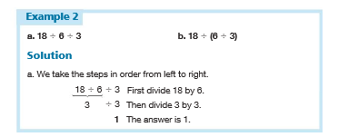

Solve b: 18 (6 3) =

Did you get the same answer as a? If no, why not?
Work out the following examples:

Important note: If there are no parentheses. Solve from left to right.

144 8 x 6 =

Important note: If there are parenthesis. Solve parentheses first.

144 (8 x 6) =

Only _____ numbers are involved in _____ _______ of a _________. If ____ numbers are added (or multiplied) changing the two numbers selected for the first addition (or first multiplication) _____ _____ ______ the final sum (or product).

Example:

(2 + 3) + 4 = 2 + (3 + 4) (2 x 3) x 4 = 2 x (3 x 4)

This property applies to ___________ and __________ and is called the ___________ _____________.
As shown by examples 1and 2, the Associative Property _______ __________ apply to subtraction or to division.

Associative Property of Addition:

When____________ the ___________ of the numbers that are ___________, the ___________ will always be the ______.

Note: It does not apply to subtraction

Write down an example:

Associative Property of Multiplication:

When __________the ___________of the numbers that are ________, the ___________ will always be the _____________.
Note: It does not apply to division

Write down an example:

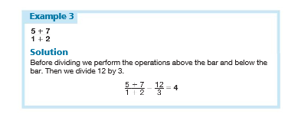
Practice Problems

- 16 – 3+ 4 = | - 16 – (3 + 4) =
- 24 (4 x 3) = | - 24 4 x 3 =
- 24 6 2 = | - 24 (6 2) =
- 6 + 9 =  3 | - 12 + 8 =  12 - 8
- Rewrite problem g using parentheses instead of a bar.

